Ministry of Education and Science of Republic of Kazakhstan



**Department of Computer Engineering and Information Security**

Fundamentals of Information Security

**Laboratory Work 3**

Submitted by:

Alfaraby Nursultan 26498

Group: CSSE-1801 SWD-1

Submitted to: Alipbekov A.

Almaty 2021

Here how it looks on the phone:

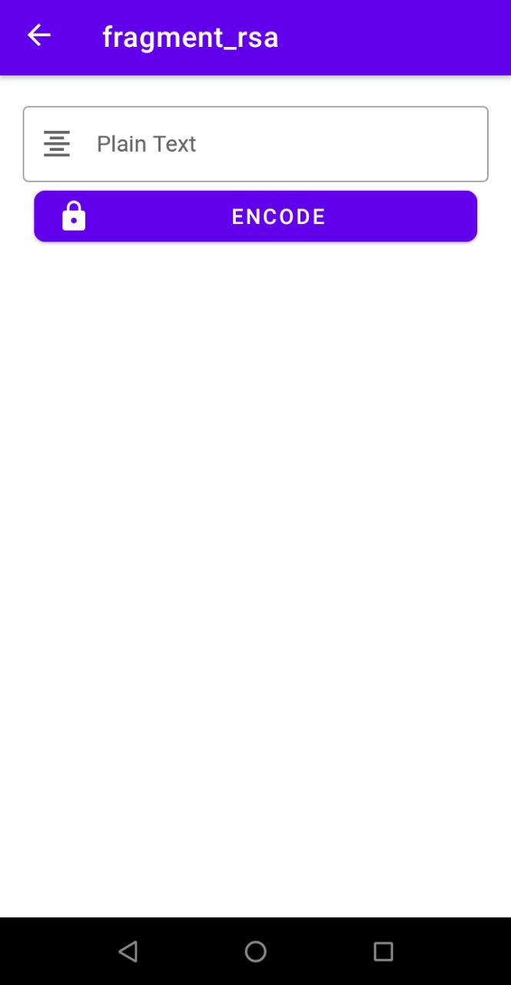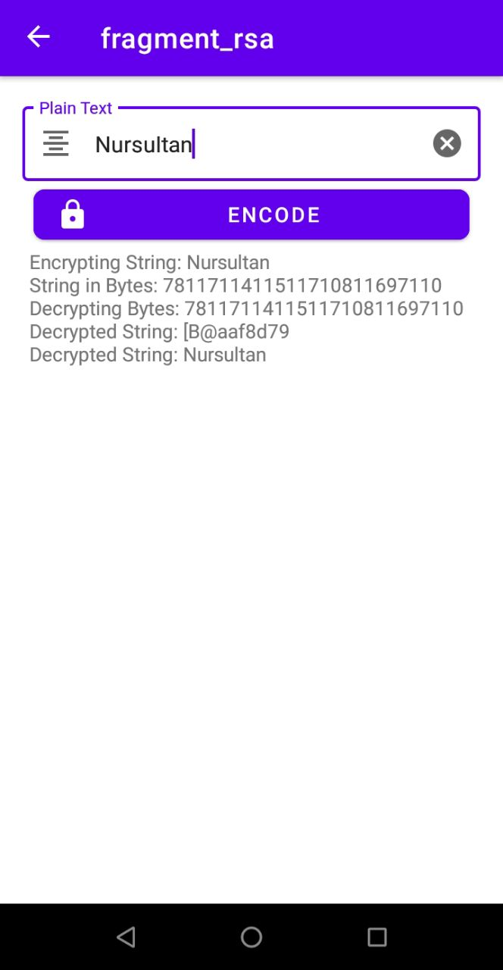

The new Hub Looks like the following:

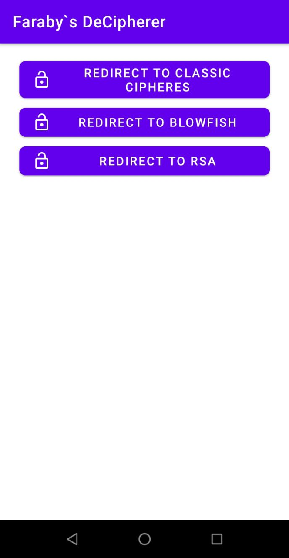

Here what I do on button press, by creating a class that does most of the job and returning correct output

